Welcome, and thank you for participating in our study.

The introduction of whole slide images (WSIs) 20 years ago provided an immense opportunity for sharing and for algorithms to assist pathologists’ reading tasks. Today, we invite you to review 120 WSIs for us to capture how you as an expert examine these complex images. The experiment will consist of three parts: a short training session to get you familiar with the procedure of the experiment, the formal experiment, and an exit questionnaire.

Before we begin, we will calibrate our eye tracker using a 9-point calibration. A white dot will appear on the screen. Please follow the dot as it moves on the screen. Please sit comfortably and do not be too close (<0.5 meter) or too far (>1 meter) from the screen.

<Do calibration>

# Training

<Load the training interface.>

During this training session, please ask any questions you may have. When the formal experiment begins, we will not be able to answer any questions.

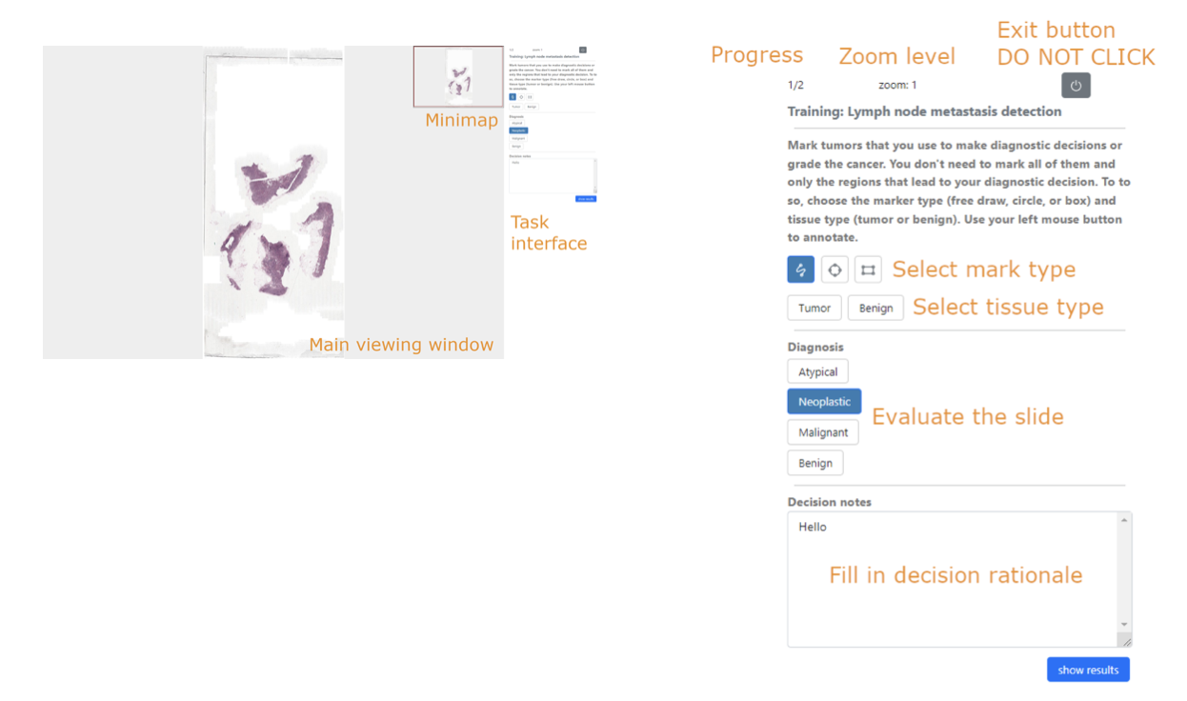

*Figure 1: OSU WSI Reading Testbed*

Here is the interface you will be using today. The main view shows an example of a lymph node WSI at its lowest magnification. You can zoom using the middle-mouse-wheel and pan by left-mouse-drag. The current zoom level is shown in the upper-right corner of the screen.

<Now please try pan and zoom.>

The mini-map in the upper-right corner shows a miniature version of the whole slide, with a red rectangle showing the current view of the main viewer relative to the whole slide. Left-mouse dragging of the red-box will also change the main view.

<Now please try to drag the red-box in the minimap to update the main view.>

To mark a tumor region, choose a mark type from the three choices (free draw, circle, or box)**, as well as a tissue type from two options **. In the main view, use left-mouse drag to annotate. Tumorous tissues will be in green and benign in blue. You can also mark a donut shape using two embedded labels.

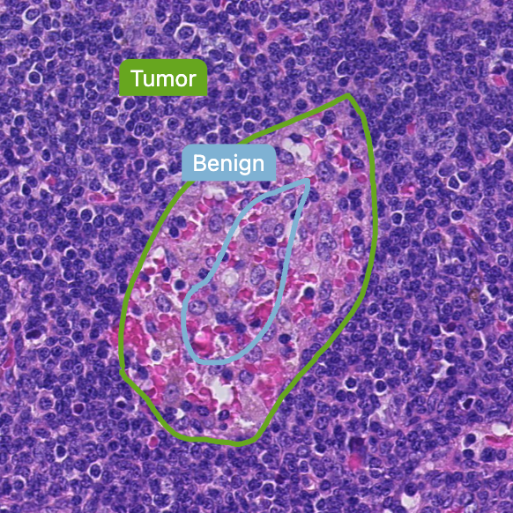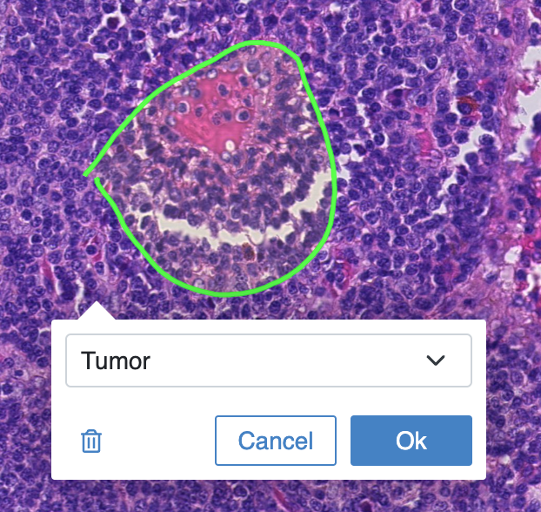

To move your annotation to another location, please click INSIDE an annotation (it will turn to semi-transparent yellow), and then use left mouse drag to move. Left-clicking inside the annotation also brings up the dialog window.

1. to change the tissue type, click the arrow next to the type; and
2. to remove a mark, please use the small “trashcan” icon to remove.

Then click OK. (*Please note that for changes to take effect, you* ***MUST*** *click the OK button to save your changes.*)

<Now please try to mark, remove, edit the labels.>

Please be noted that you don’t need to mark all regions, just be sure to mark those that lead to your decision. Except for those benign conditions, you **MUST** mark at least one region as cancerous that leads to your decision.

Next, please input your evaluation and a brief rationale for your decision. There is no order of these actions. You can change these before you click the “NEXT” button to move on to the next tasks. You will see two tissue types belonging to lymph node and prostate, please grade accordingly.

At the top of the interface is the current progress in the experiment (for example, 1/120 shows the 1st task among 120). Click the PAUSE button (the small black button) if you need a break. Please feel free to take a break at any time after completing your current image.

During the training we show you the ground-truth. During the formal study, these data will not show. If you have not answered all required questions, a warning will appear telling you what question still needs an answer.

This is the end of the training. Are you ready to begin?

Please complete the tasks as accurately and as quickly as you can. There will be a 2-minute break every 30 minutes.